**Name: Divya Sree Murali**

**Date:5-11-2024**

**Hands on Exercise for pet adoption database**

**1.Store Data**

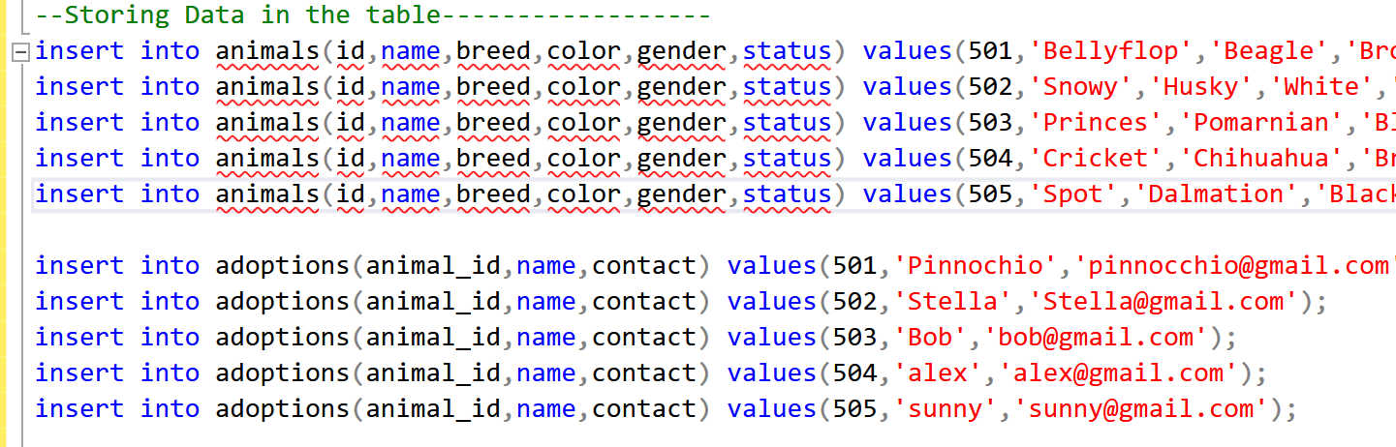

**2.Update data**

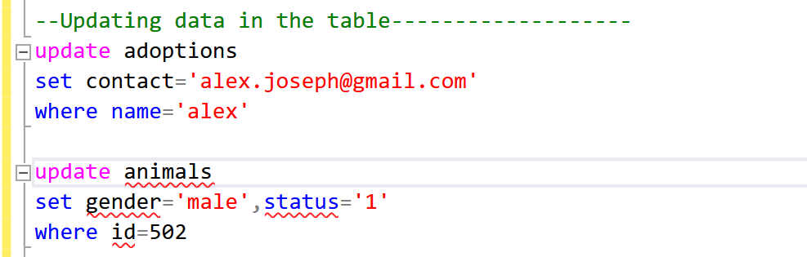

**3.Delete Data**

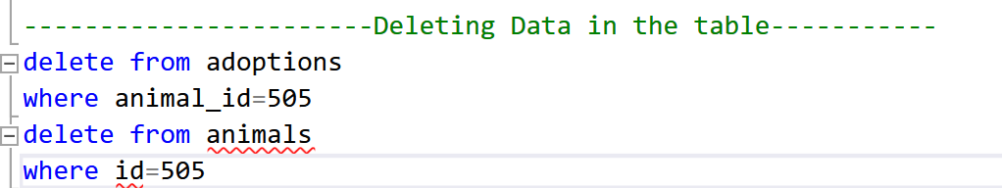

**4.Retreiving specific attributes**

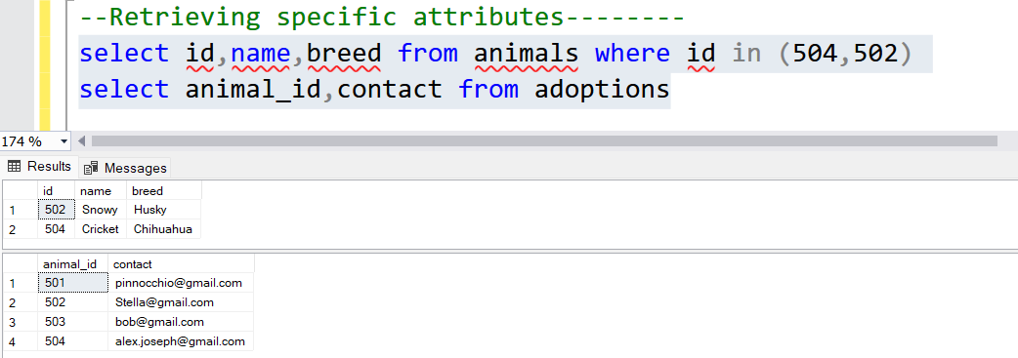

**5.Retrieving selected rows**

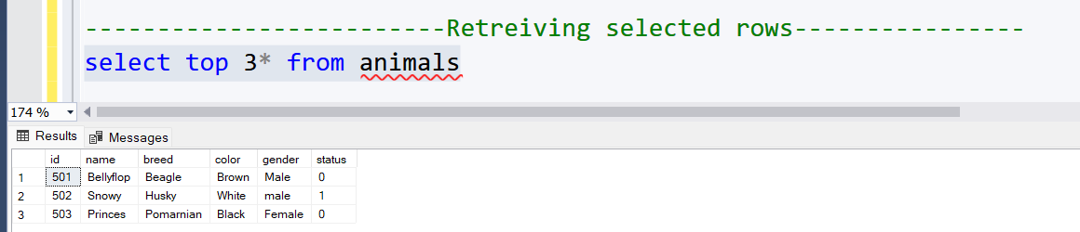

**6.Filtering data**

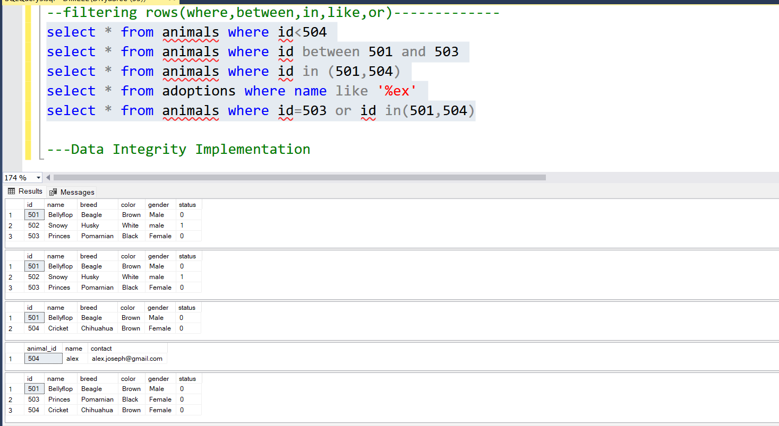

**2.1.Data Integrity**

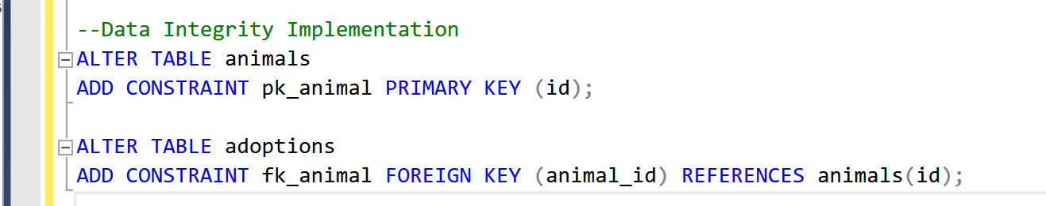

**2.2.String functions**

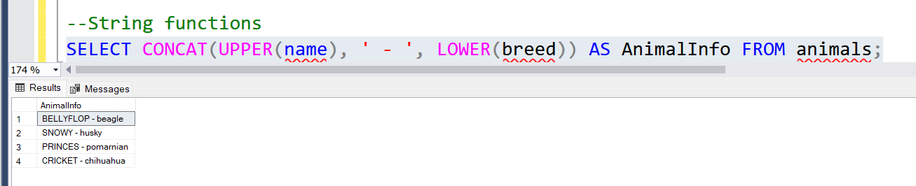

**2.3.Aggregate functions**

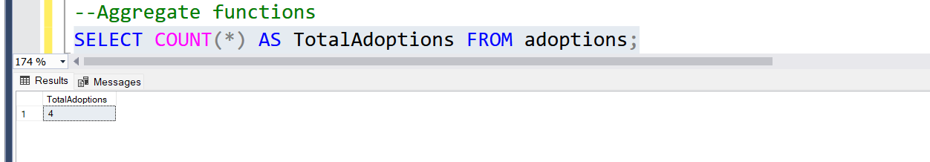

**2.4.Group by**

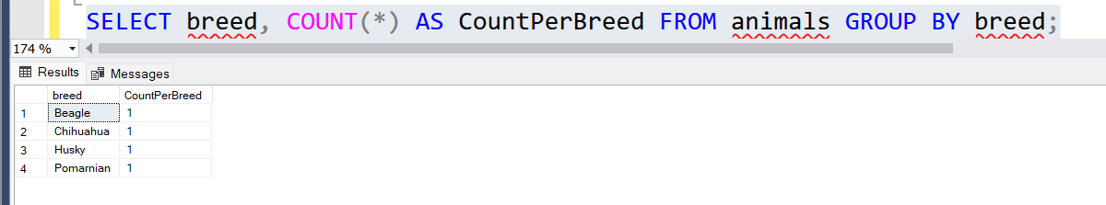

**2.4.Order by**

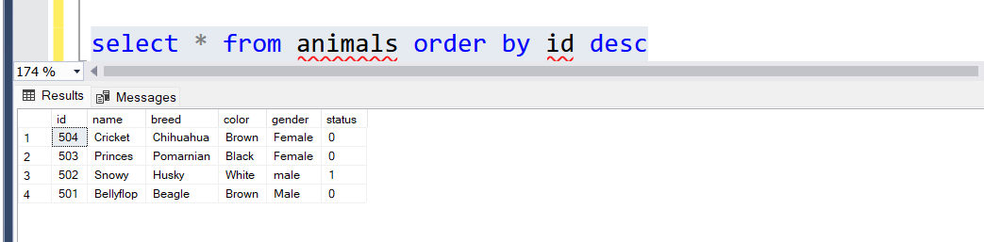

**2.5. Group by and having**

